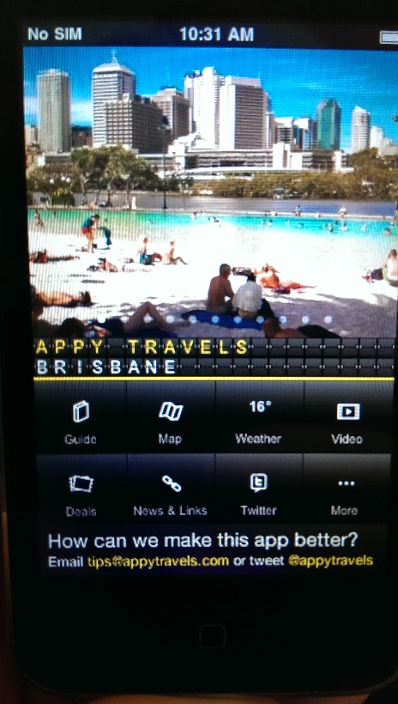**Brisbane Travel Companion – By Appy Travels**

*Brisbane Travel Companion* is a free travel app available on Android and iOS. It aims to serve as a complete travel companion (as the name suggests), providing the user with maps, videos, weather and anything they might need information about on a holiday. While this version of the app is for Brisbane, there are also versions for many other cities and areas around Australia and the US (with more being added frequently).

The test device for this app was an iPhone 3 running iOS 4.2.1 (screen capturing was not possible, through no fault of the app, so screenshots were done with a separate camera).

**Features**

* Guide
* Map
* Weather
* Video
* Deals
* News & Links
* Twitter
* Currency Converter
* Phrases
* Nearby Destinations

**Guide**

Most of the functionality that Brisbane Travel Companion offers up is in the guide section. It contains information on attractions, restaurants, bars and accommodation in Brisbane. If the user sees somewhere they may want to go, perhaps a café or market, they can select the location to bring up more information (including address, description and external website) as well as a map for navigation. This appears to be a very useful feature for a traveller as they can not only see information on a smorgasbord of venues, but view the location on a map (see Map section below).

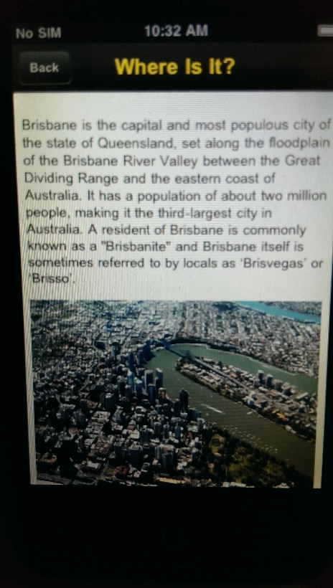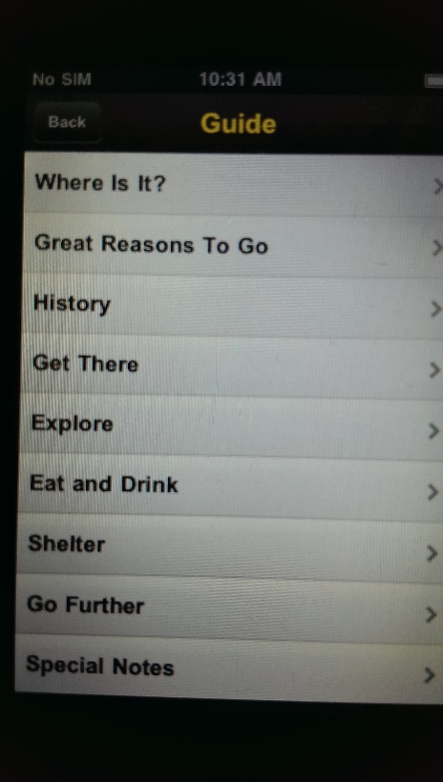

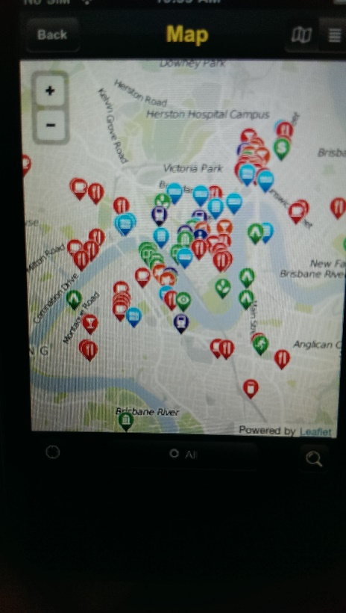

**Map**

Brisbane Travel Companion also features a mapsection. This can be seen as the primary navigation tool for the app. It displays all locations a tourist may want to visit, categorised by type (accommodation, attractions, etc.), on a graphical map or in a textual list. More information on a particular location can also be viewed.

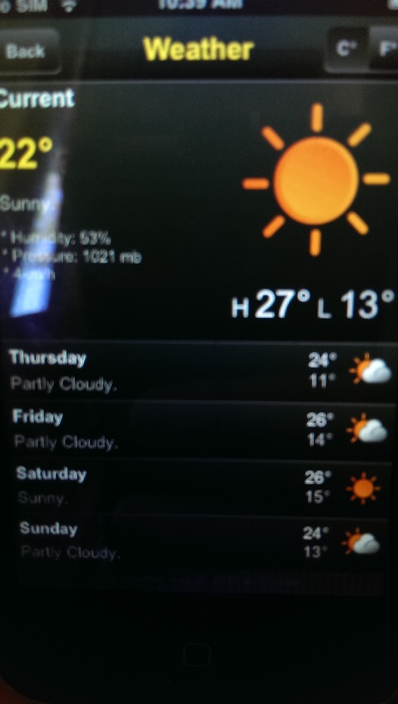

**Weather**

One thing that can really ‘dampen’ a holiday is bad weather. This is why Brisbane Travel Companion includes a **Weather** section. The current weather in Brisbane is shown, along a forecast for the next 4 days. The location is set to Brisbane City and cannot be changed to surrounding suburbs. Weather can also be updated by pulling down on the page.

**Extras**

There are also some more features that ‘fill out’ the Brisbane Travel Companion app (see the list at the start of Features). Some of these features offer extra functionality, particularly the Phrases section which translates common English phrases into a variety of languages, while some offer little or no functionality, the Deals tab is totally blank. While these features are not entirely necessary they do offer little extra to Brisbane Travel Companion, increasing its versatility and preventing the need for many separate apps.

**Summary**

Overall, this Travel app is easy to navigate with information displayed in an easy-to-digest form. The UI is similar to many other apps on the market, with tabs down the bottom leading to each feature within the app (Guide, Map, etc.). Overall the functionality of the app is quite good. However some of the functionality is not particularly useful and makes the app feel less polished, demonstrating the need for perfecting a feature or leaving it out.

**Pros**

* Constant look and feel throughout design
* Easy navigation (tabs and lists)
* A few features with excellent functionality

**Cons**

* While the map shows the user’s location, it is not possible to retrieve directions to a location
* Some ‘filler’ content with limited or no functionality
* Design is quite plain, no ‘oomph’
* No feedback given when the app is loading

**TripAdvisor Hotels Flights Restaurants– By TripAdvisor LLC**

*TripAdvisor Hotels Flights Restaurants* is a free travel app available on a variety of platforms, including Android, iOS and Windows Phone. The app is an extension of the well-known TripAdvisor website, featuring all of the same functionality of ‘the world’s largest travel site’ (TripAdvisor, 2013). Similar to the website, through the app users can compare prices for booking hotels, flights and restaurants. All of the destinations are reviewed and ranked in stars by users of the site.

The test device for this app was an iPad 2 running iOS 5.1.1.

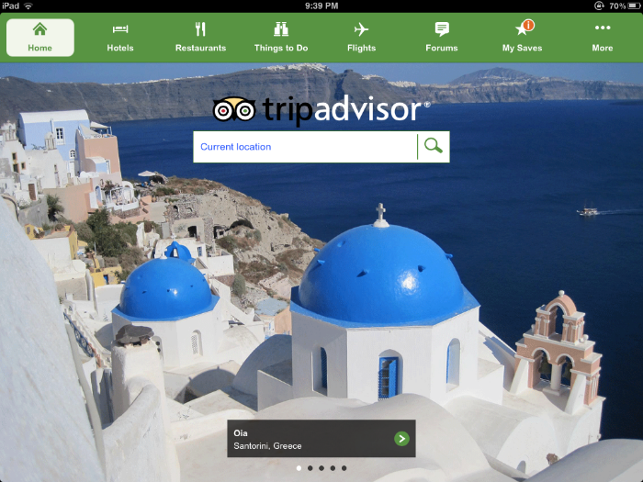

**Features**

* Current Location Search
* Hotels
* Restaurants
* Things To Do
* Flights
* Forums

**Hotels, Restaurants, Flights**

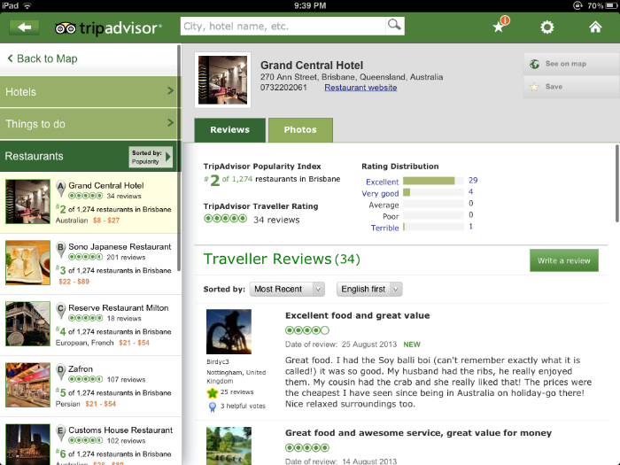One of the most famous and user friendly features of the TripAdvisor website is the ability to see what other users think of a hotel, restaurant or airline. This allows the user to see what others think of a location or service and make a decision accordingly. TripAdvisor even ranks hotels and restaurants based upon user ratings. To post a comment or review on a location/service a user must first create an account with TripAdvisor. This registers them with the app and gives them a profile to use within all apps and the website. All reviews and ratings are based upon user created content.

The app offers many search capabilities for users:

* Hotels – filtering date, price, property type, location and more
* Restaurants – filtering by price, cuisine and location
* Flights – filtering by locations, date, number of travellers and class (eg. economy, etc.)

These make comparing many hotels, restaurants or flights a breeze. Users can also bring up a map of a requested hotel or restaurant, to aid in navigation.

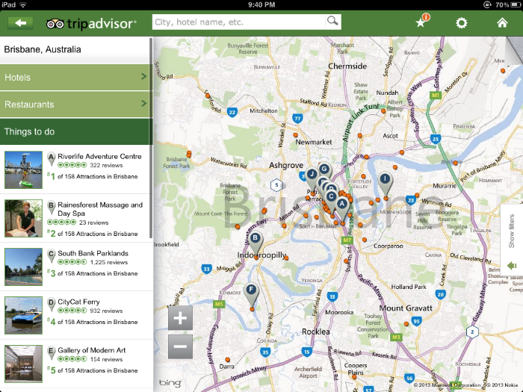**Things To Do**

The Things To Do section of TripAdvisor extends the functionality of the app to include user rating and reviews of activities and attractions within an area. For example, the *Riverlife Adventure Centre* is the #1 attraction in Brisbane. The location of an attraction is also displayed on a map, and can be filtered by type (eg. bar, cultural, etc.). This is a great function and would likely prove useful on a holiday.

**Forums**

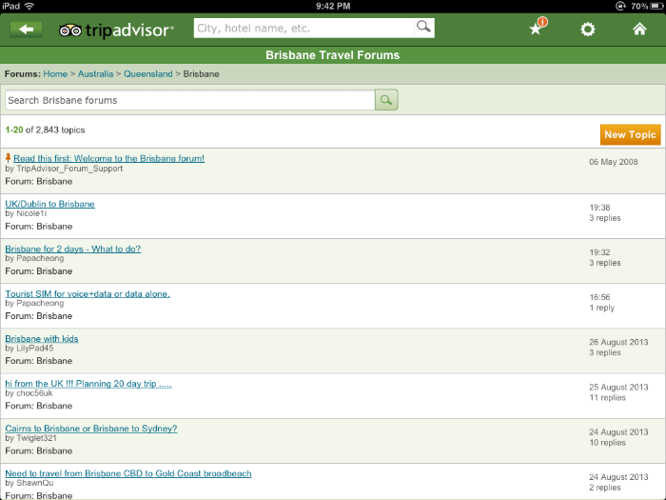TripAdvisor also contains a huge Forums section with user created questions and discussions. Within this sections this is a seemingly endless list of forums for nearly every city on the planet. Due to the large user base of TripAdvisor (including the website), user questions are answered quickly and discussions can be spread over many pages. This ‘encyclopaedia’ of knowledge is invaluable when feeling lost in an unknown, foreign country. It is easy to search through as well, allowing filtering by country, city and search terms. Users within the TripAdvisor community are mostly welcoming and happy to help a fellow traveller.

**Summary**

TripAdvisor is an incredibly polished, well-designed app. Its main functionality lies in comparing hotels, restaurants, flights and attractions, but it also has a *bulging* forum section. It also allows users to engage in a community of other travellers and share their wonderful (or awful) travel experience for others. Navigation is very easy over the various screens, featuring tabbed and list based views. All styling is consistent and centres around green, making each section of the app feel very connected. Overall a near perfect travel app for a wide audience.

**Pros**

* Easy to navigate (includes back button)
* Huge amount of information
* Fast loading times
* Lots of polished functionality
* Constant look and feel, modern
* Very little data is stored on users device (all network accessed)

**Cons**

* Information is user created (unverified)
* User must create an account to post information (app must store sensitive information)
* Totally network dependant, an internet connection may not always be available when on a holiday